**P2 - Demonstrate the use of object oriented tools and techniques** & **M2 – Give reasons for the tools and techniques used in the production of an object-oriented application**

**Classes and Methods & Encapsulation**

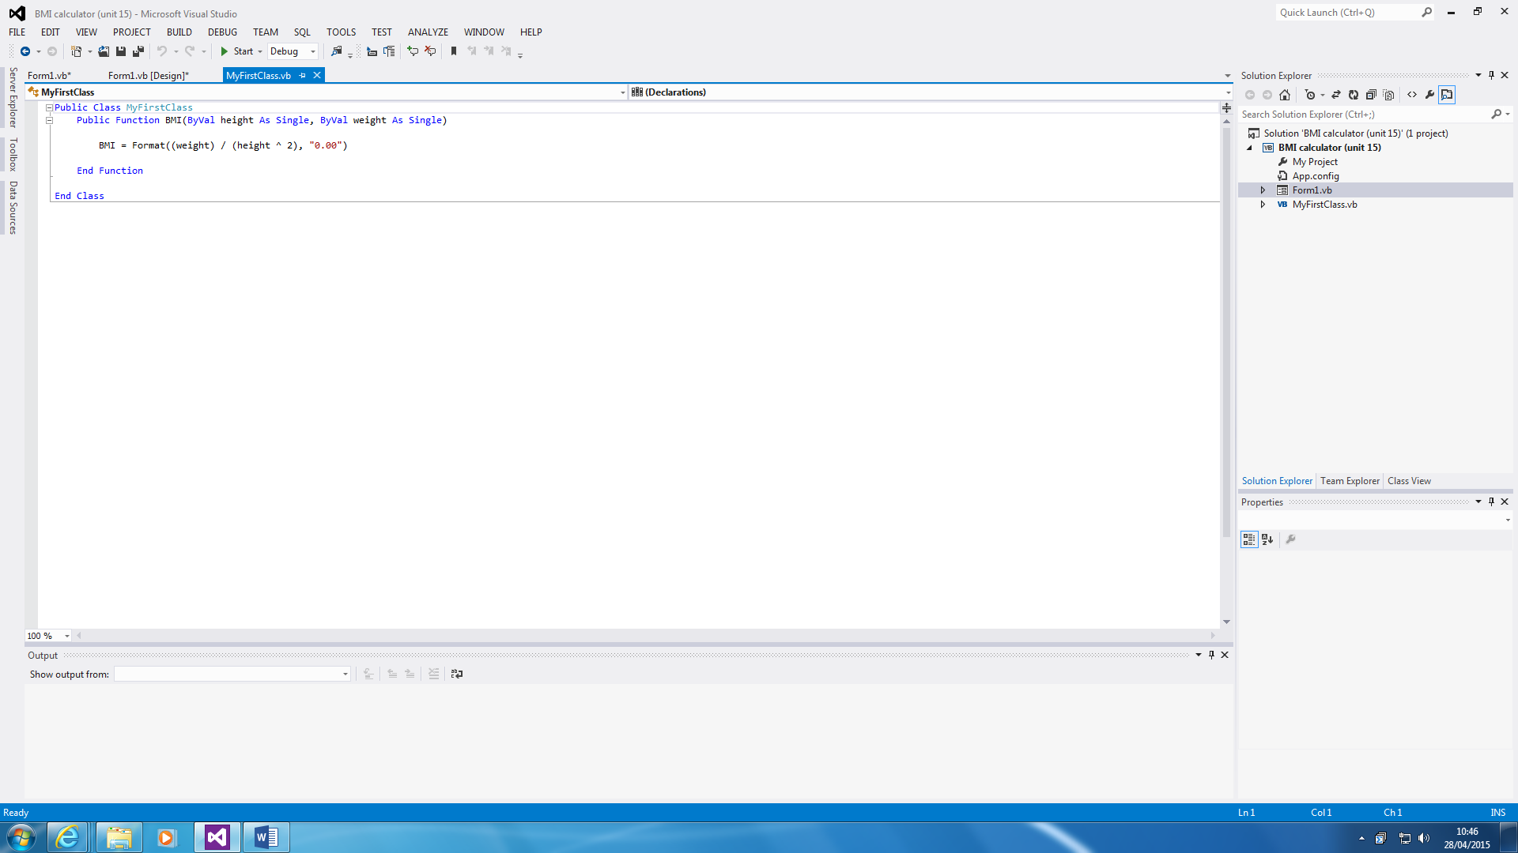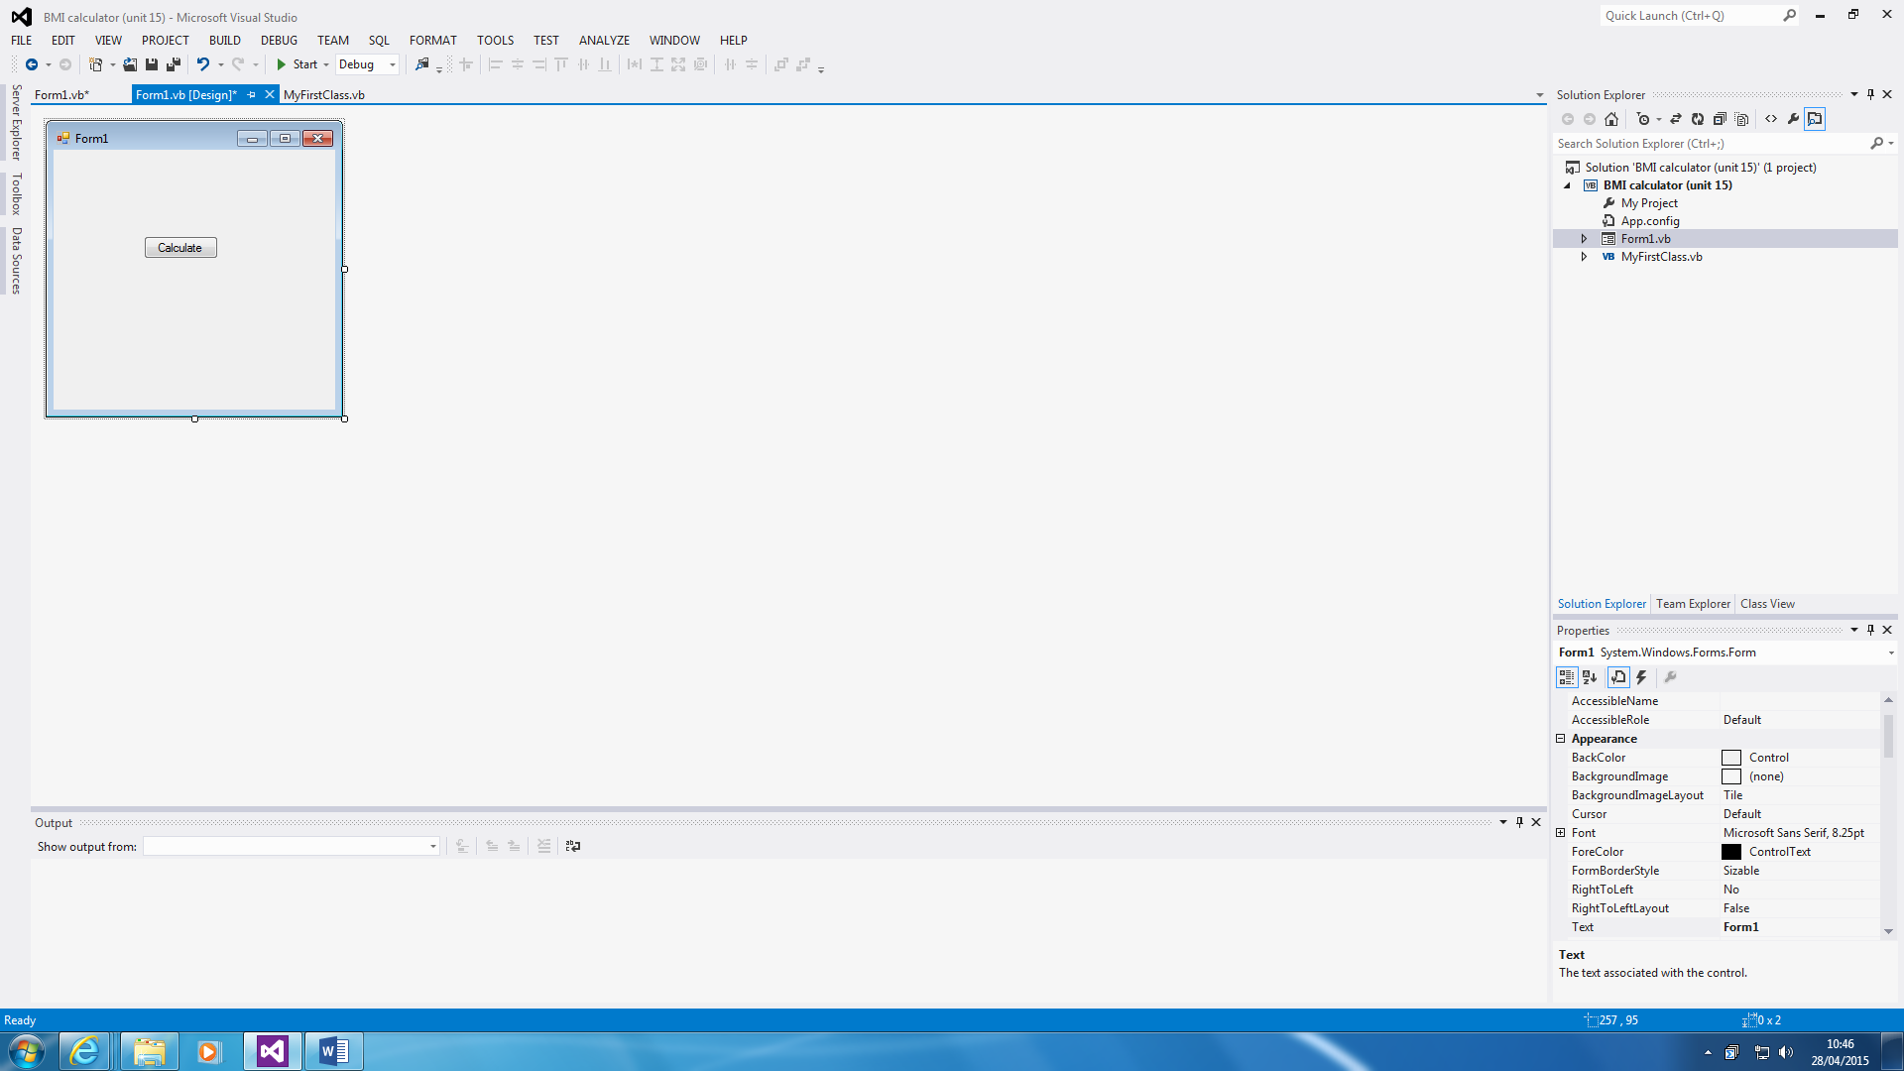

Class

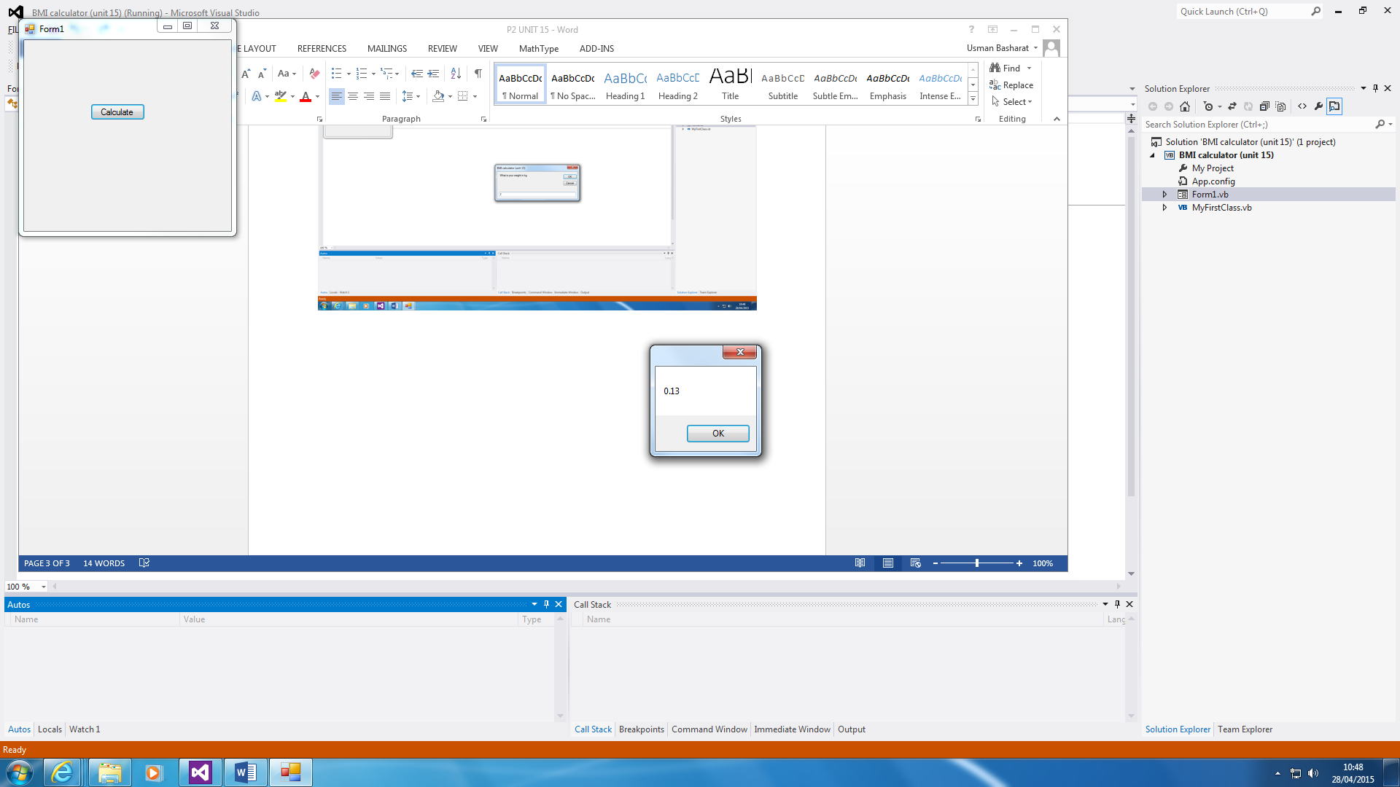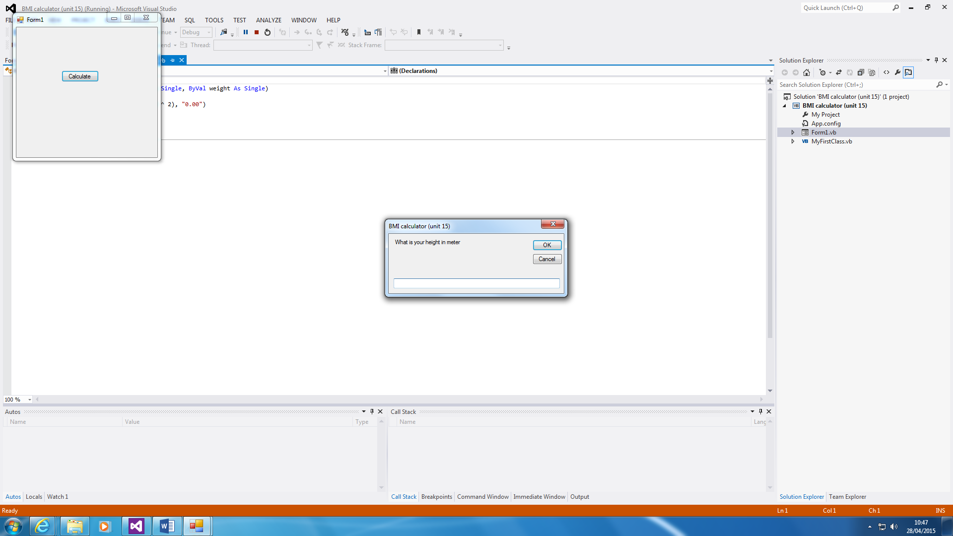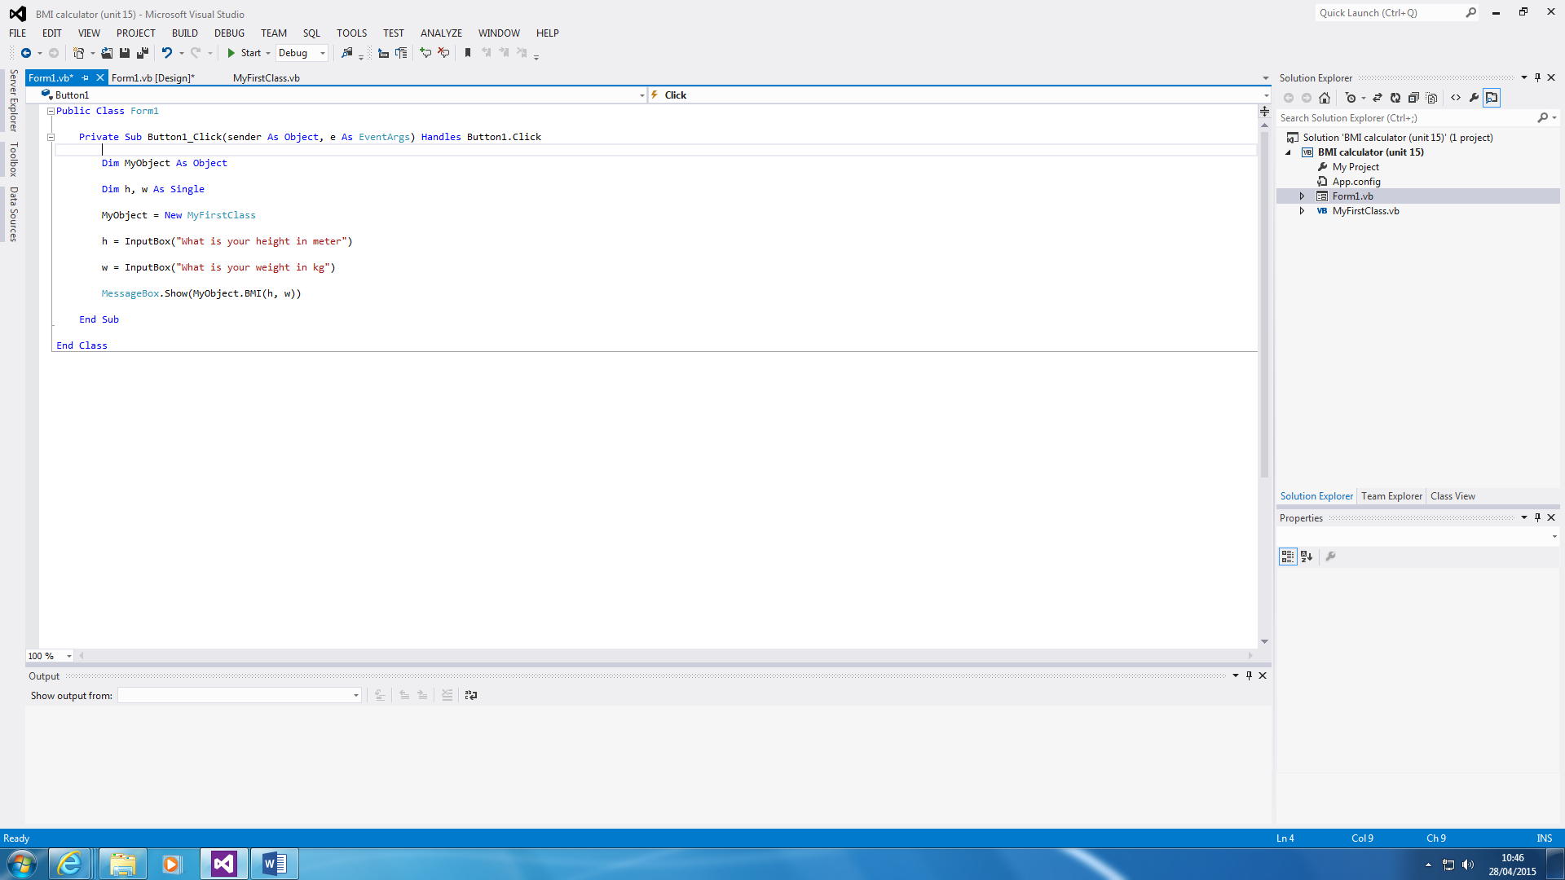

Method

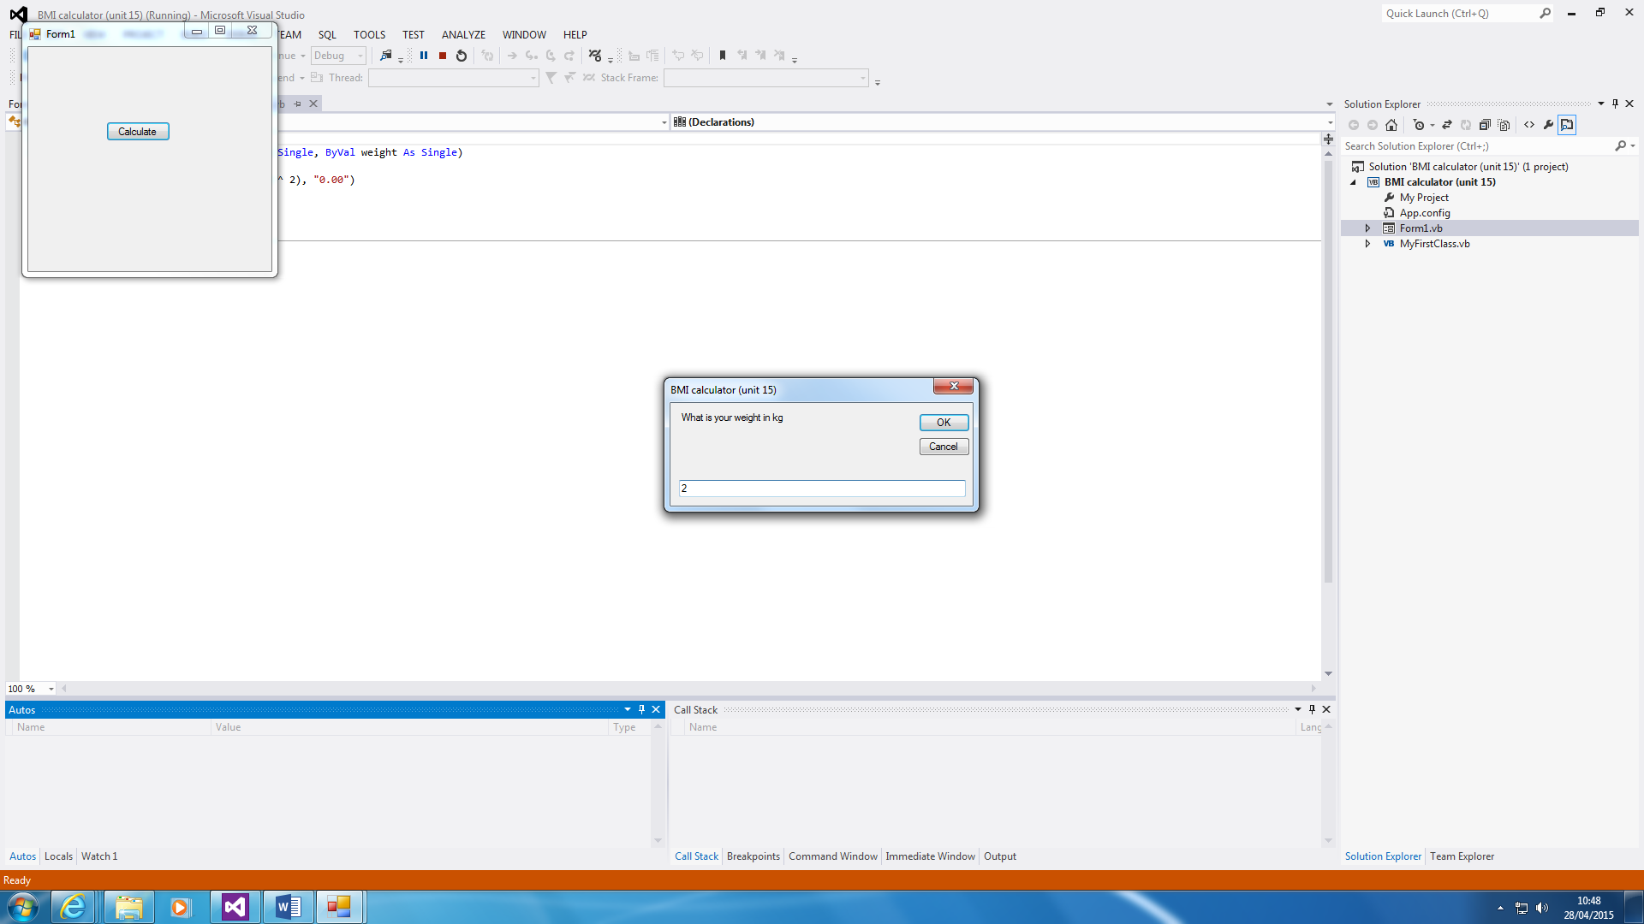

This is a BMI calculator. This demonstrates classes and methods shown on the screenshots above. Both of them interact with each other to make a BMI calculator. As you can see, ‘MyObject’ is connecting the Form with the Class to enable the communication. The first instruction that is set for the computer is to put up the InputBoxes. The second is to add them together by connecting the class with a MessageBox shown to do the calculation. The last screenshots show how the calculator works. This is done the user answering both questions. The answer is shown as a MessageBox, as shown above.

Encapsulation is shown above. Private and Public is shown and the difference is that Private is not shown whereas Public is shown. These two are both linked with each other. However, one does not show it.

**Variable – Static**

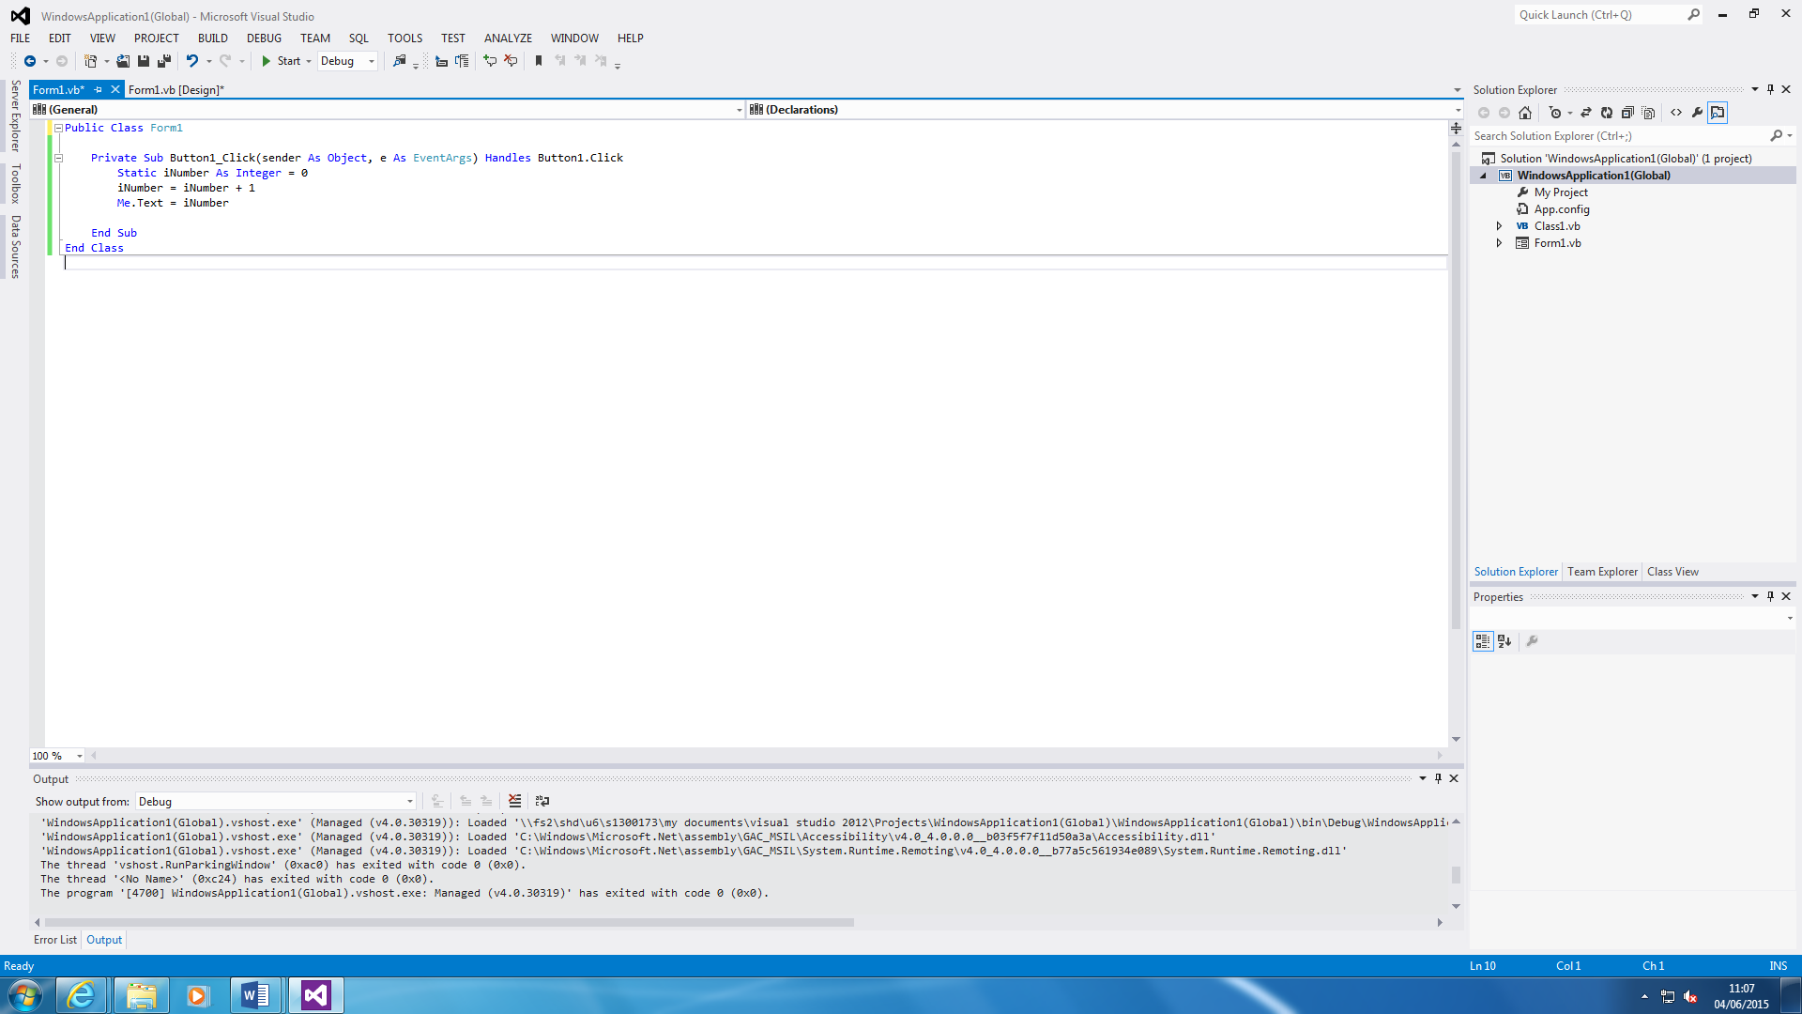

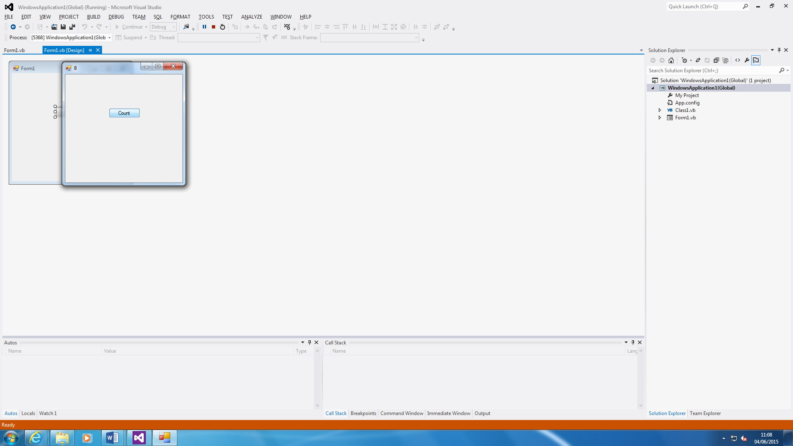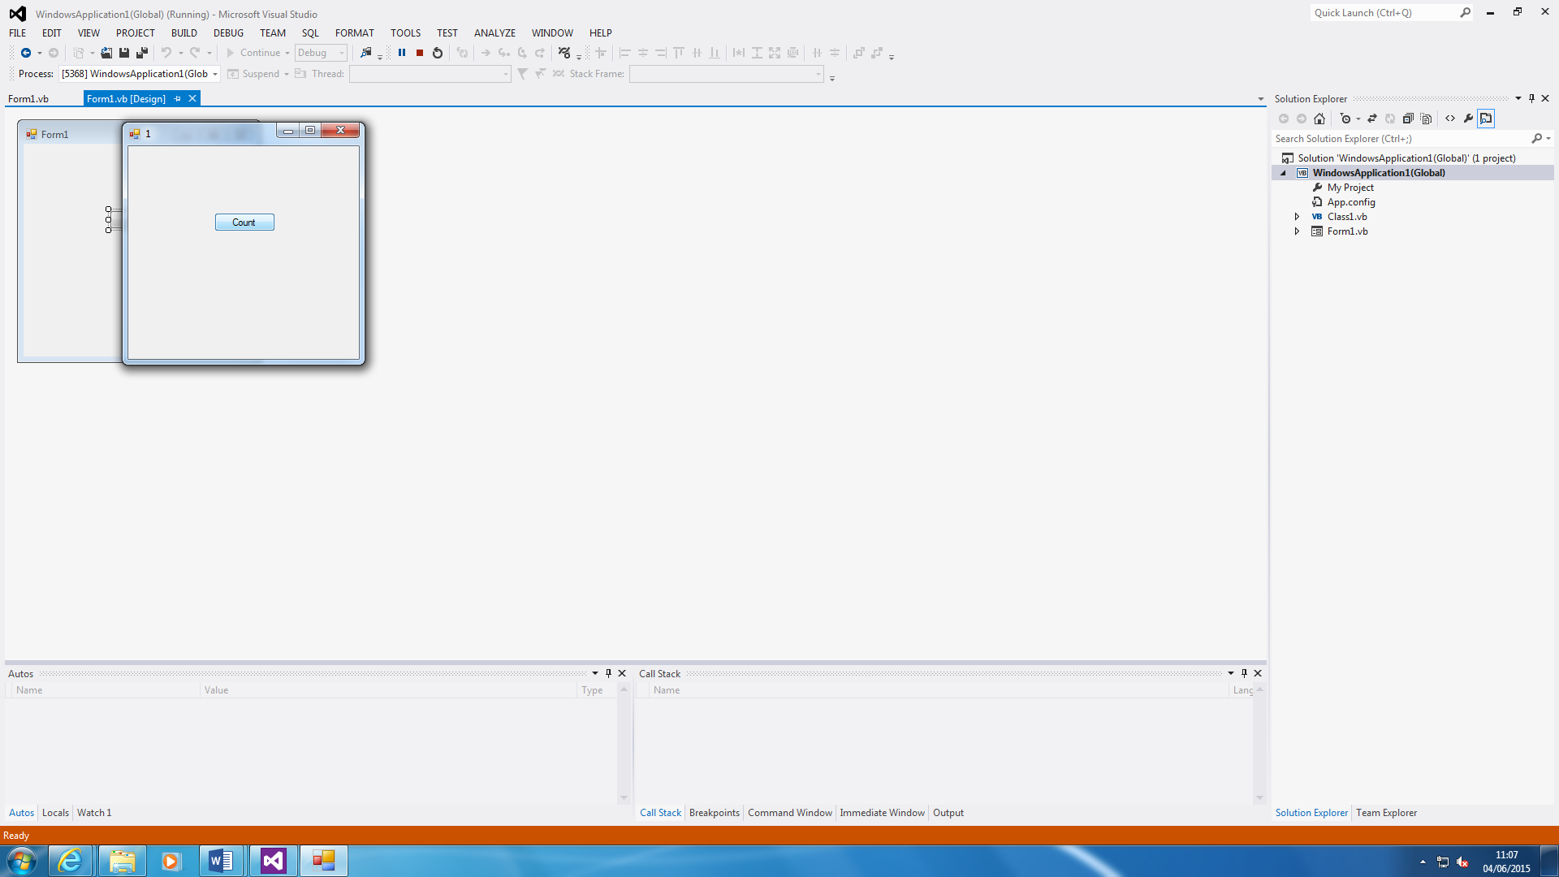

This is the Static variable that allows the user to count from 1 to how many times the button has been clicked. It is variable from 0 to 1. Static is always from 0. You have to define a character and equal it to 0. This is a classic example of how Static is used.

**Debugger**

This is one of the common errors that I receive during my project. It shows that the value typed in cannot be converted into a string. This shows that it either needs to be verified by a variable or it needs to be added to something.

For me, the error is that I need to add, “.Text” at the end of it to make the connection between the Textbox and the word. This way, the error is erased. Furthermore, other errors that I have found is ending the If statement with End If.

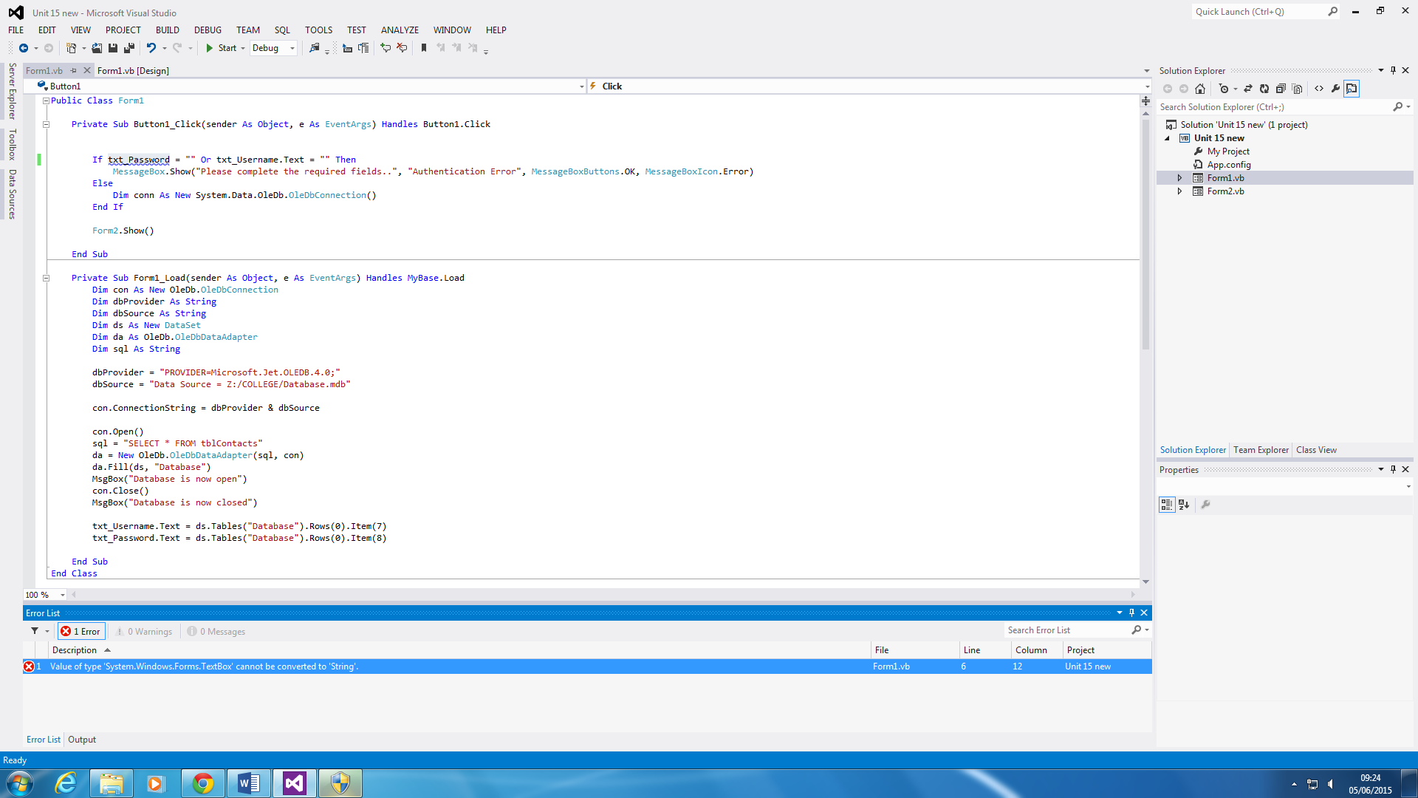

**Reference**

<http://www.webopedia.com/TERM/I/integrated_development_environment.html>